|  |  |  |
| --- | --- | --- |
| **LAB101 Assignment** | **Type:** | **Long Assignment** |
| **Code:** | **C.L.P0005** |
| **LOC:** | **295** |
| **Slot(s):** | **4** |

**Title**

Airline Reservations.

**Background Context**

An airline reservation system (ARS) is part of the so-called passenger service systems (PSS), which are applications supporting the direct contact with the passenger.

ARS eventually evolved into the computer reservations system (CRS). A computer reservation system is used for the reservations of a particular airline and interfaces with a global distribution system (GDS) which supports travel agencies and other distribution channels in making reservations for most major airlines in a single system.

**Program Specifications**

At the beginning of your program, you will ask the user to enter the name of the file with the flight information. Assume that each flight occurs daily and that there’s always exactly one flight between any two pairs of cities listed. Here’s the format of the file with the flight information:

The first line will have a single positive integer n, indicating the number of daily flights.

The next n lines will have information about each flight. Each line will contain three pieces of information separated by a space: the origin city of the flight, the destination city of the flight, and the number of seats on the flight. You are guaranteed that each city name only contains alphabetic letters and that the number of seats of a flight is in between 4 and 400, inclusive.

***Function details:***

If they choose the first option, have them enter the following information:

1. Their first name
2. Their last name
3. The origin city of their flight
4. The destination city of their flight
5. The day which they want to leave
6. The day which they want to return
7. The number of seats they want

Based on this information, either make the appropriate reservation (which is for two flights – one leaving and one coming back), or inform them that the reservation can’t be made for one of two reasons:

1. No flight between those cities
2. One of the days is invalid
3. At least one of the flights being requested doesn’t have the number of seats the user requires.

***Expectation of User interface:***

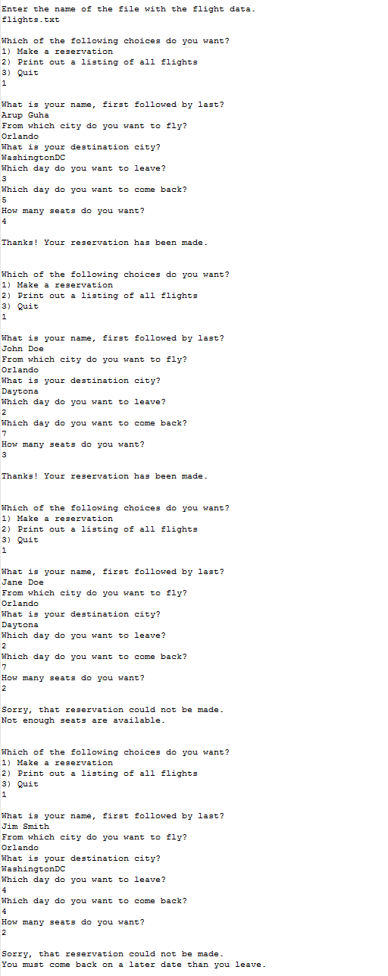

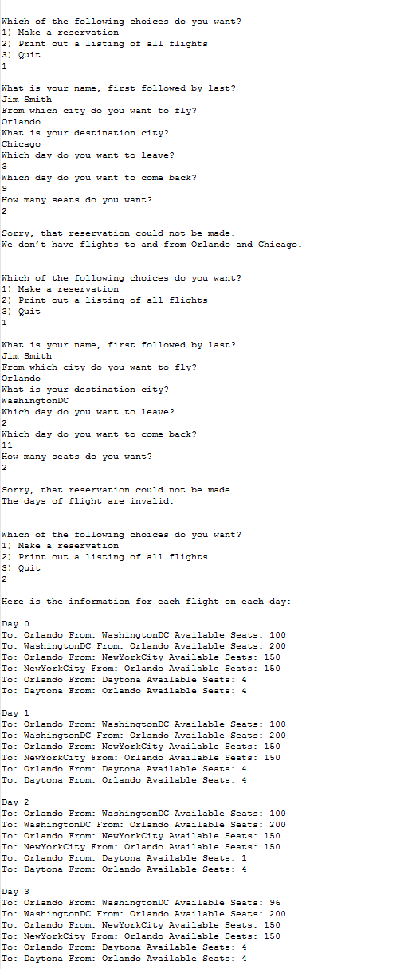

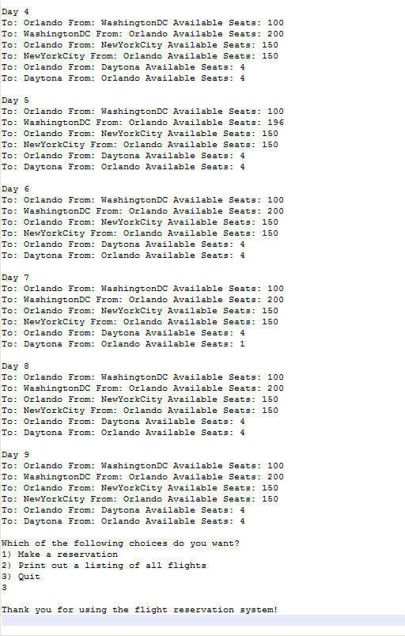

**Guidelines**

Here is a sample file:

*6*

*Orlando WashingtonDC 100*

*WashingtonDC Orlando 200*

*Orlando NewYorkCity 150*

*NewYorkCity Orlando 150*

*Orlando Daytona 4*

*Daytona Orlando 4*